**Aim**: Perform dynamic routing protocol (OSPF) and analyze the results.

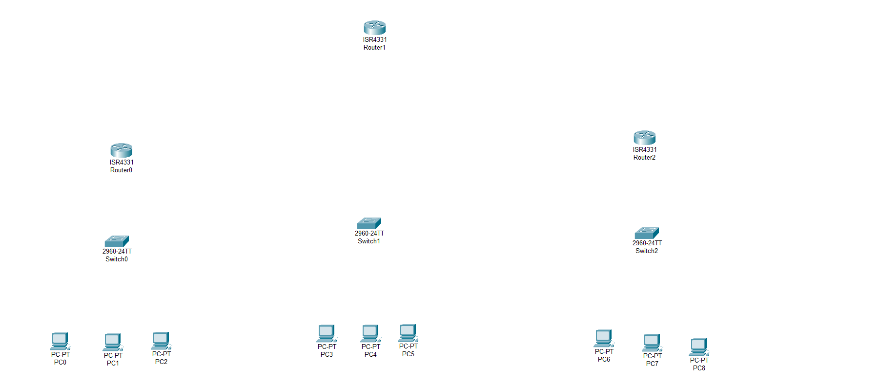**Step – 1:-** Open the Cisco Packet tracer and take three routers, three switch and nine PC’s.

**Step – 2 :-**  To long distance communication we need to connect router using Serial DTE cable. For the serial port we have to open router turn off it and drag and drop WIC-1T on router and turn on router.

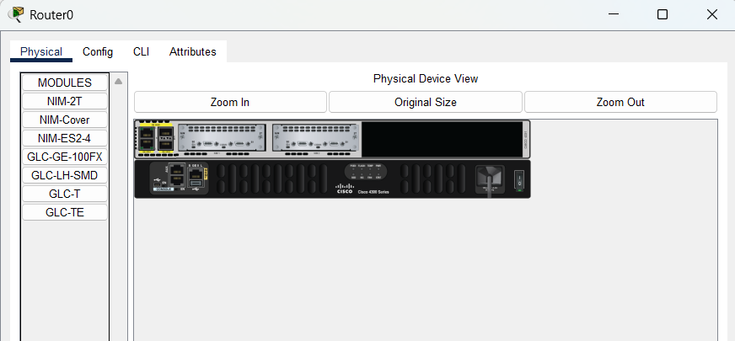

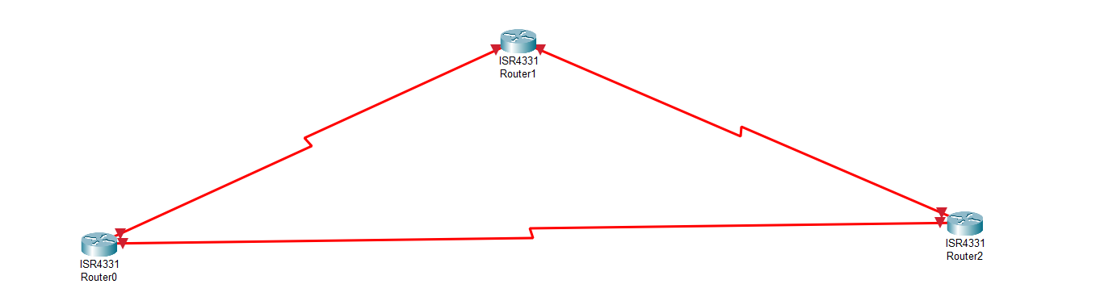**Step – 3 :-**  Now Connect Two Routers Using Serial DTE Cable.

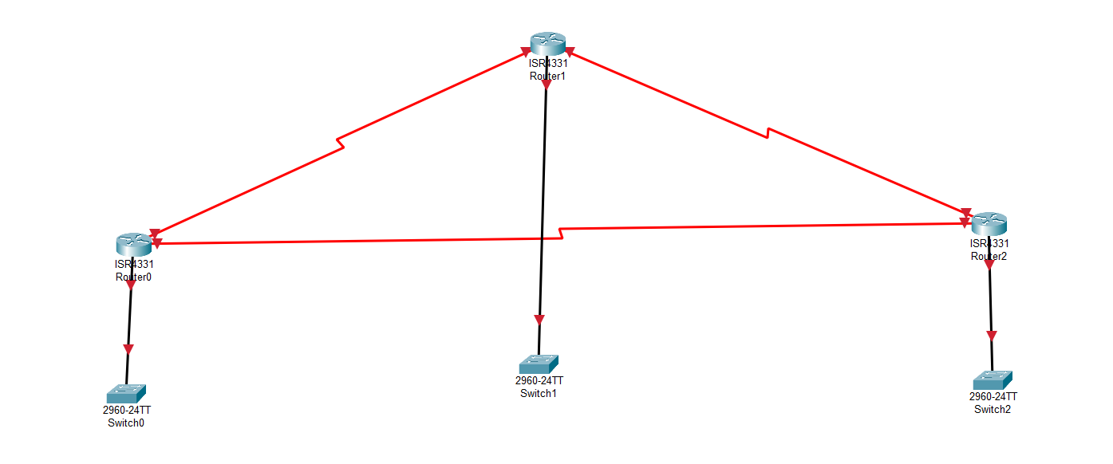**Step – 4 :-**  Now Connect the Switches with routers using Copper Straight through cable In GigaEthernet Port.

**Step – 5 :-**  Now Connect PC’s with Switches using copper Straight through cable.

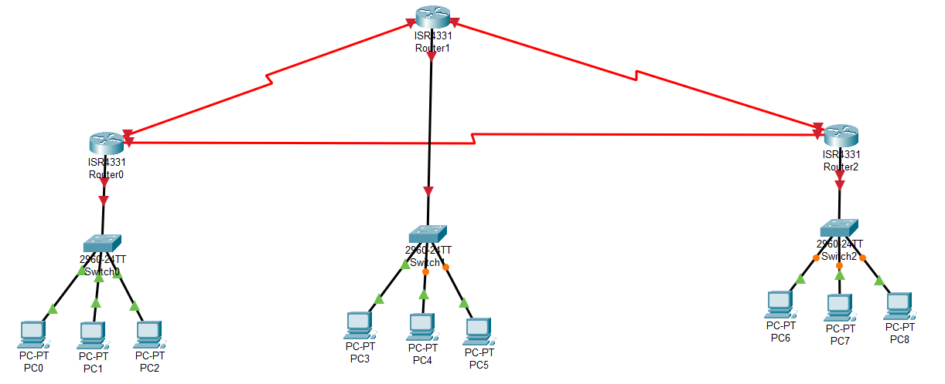

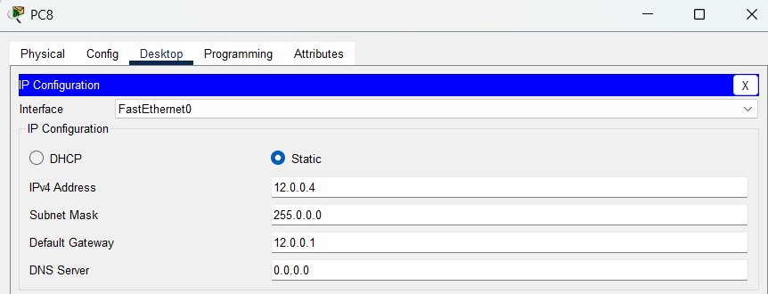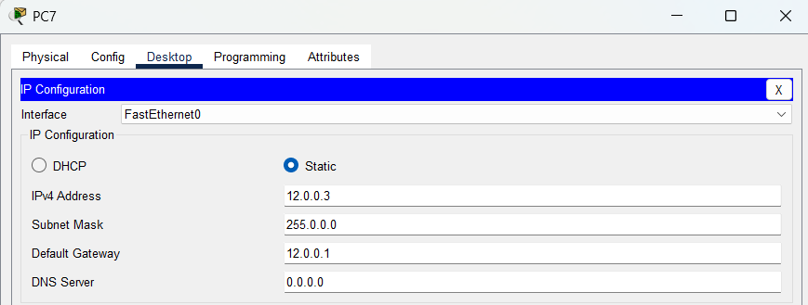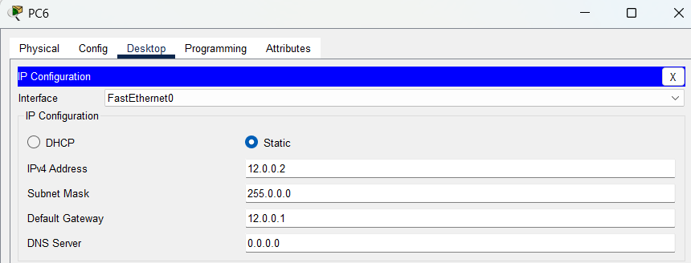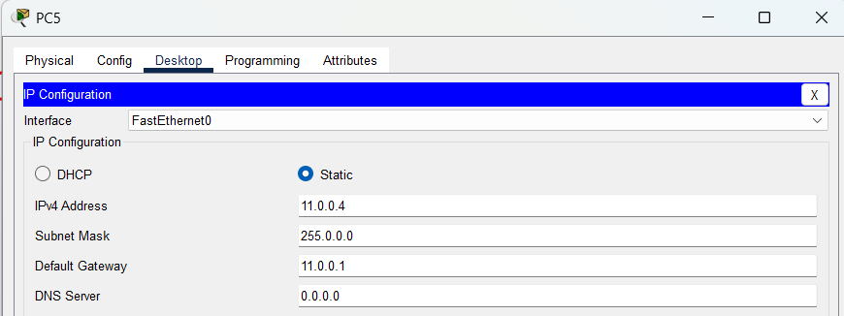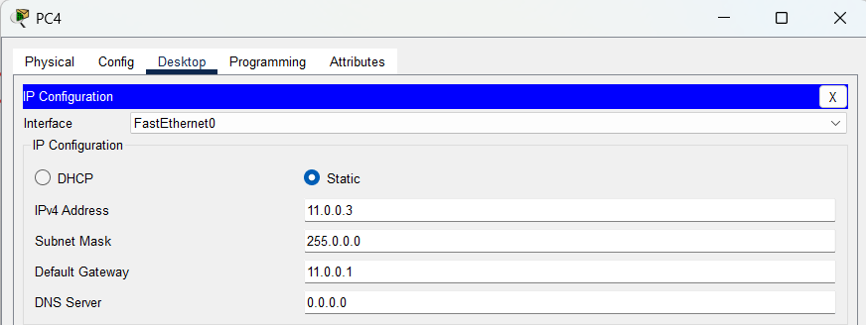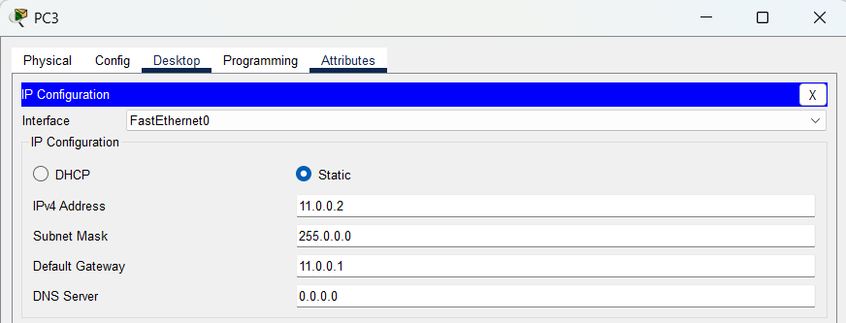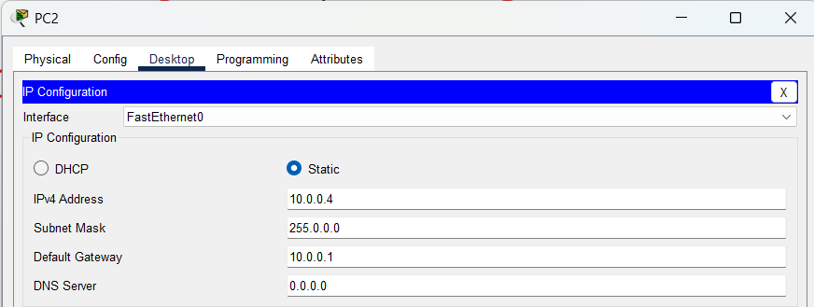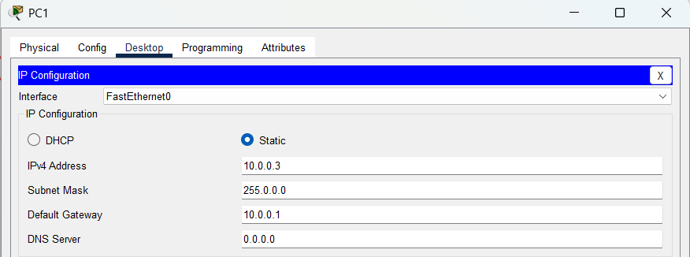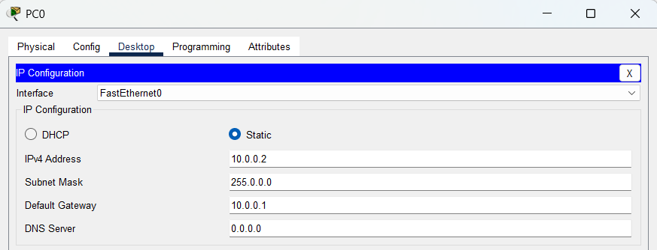**Step – 6:-**  Now assign the IP address And Subnet mask and Gateway to all PC’s.

**Step – 7 :-**  Assign IP Address to Routers

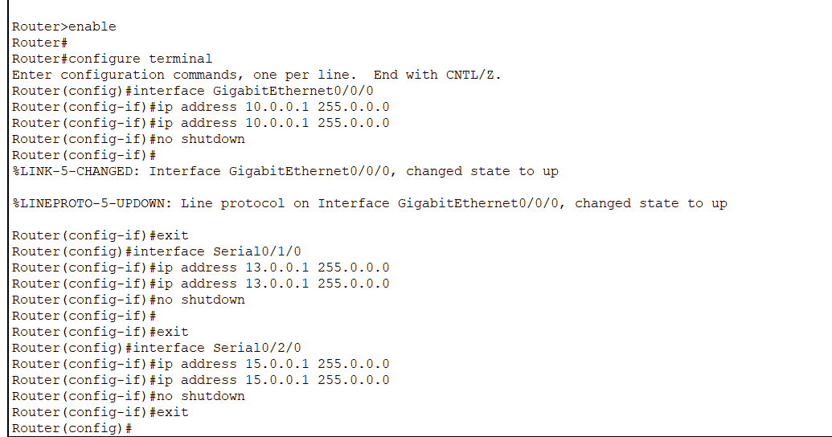Router – 0 :-

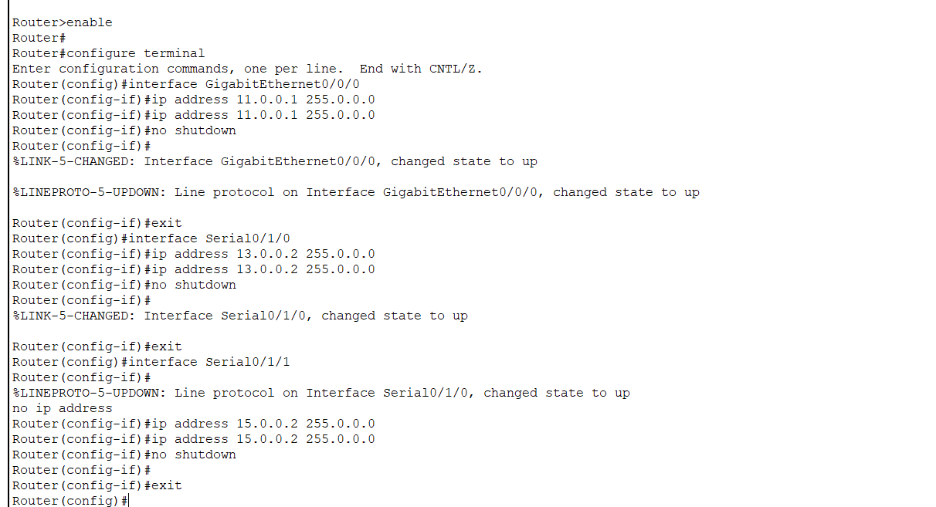Router – 1 :-

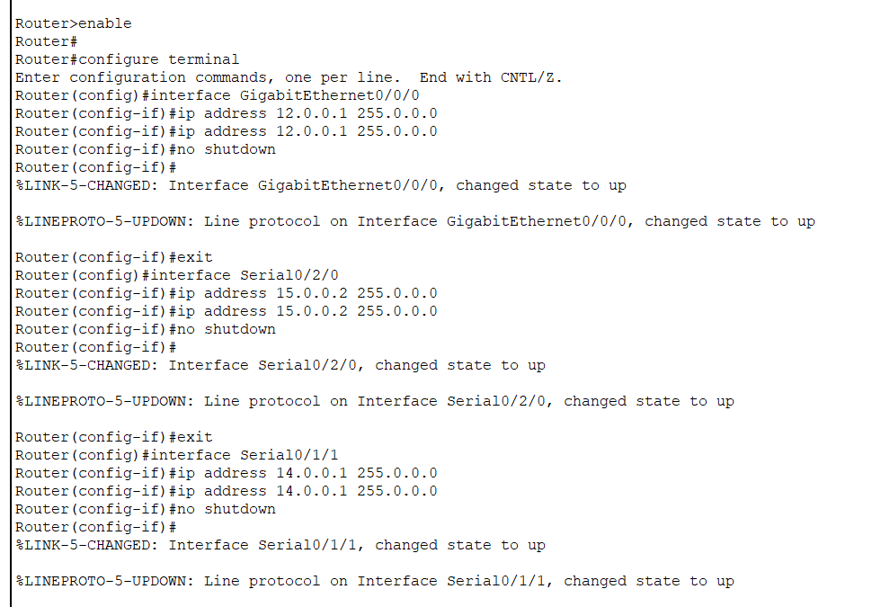Router – 2 :-

**Step – 8 :-**  now we will configure router for OSPF Protocol.

We need to implement routing protocol onto routers so that router can find destination for another network, for that in dynamic routing protocol OSPF we have command “router ospf 1” using that we entered in routers OSPF configuration mode and then we have command “network area 0”.

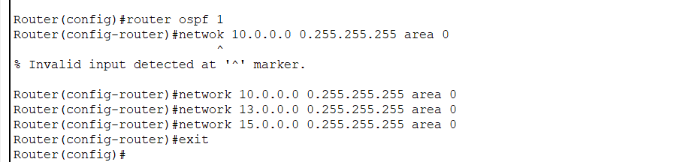Router - 0

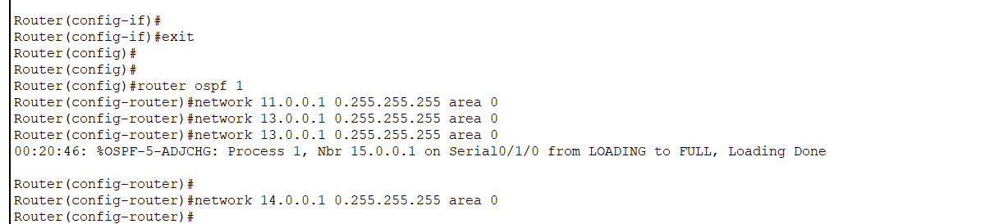Router – 1 :-

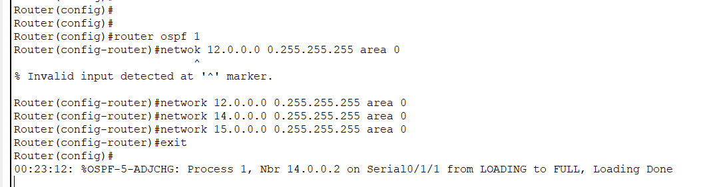Router-2 :-

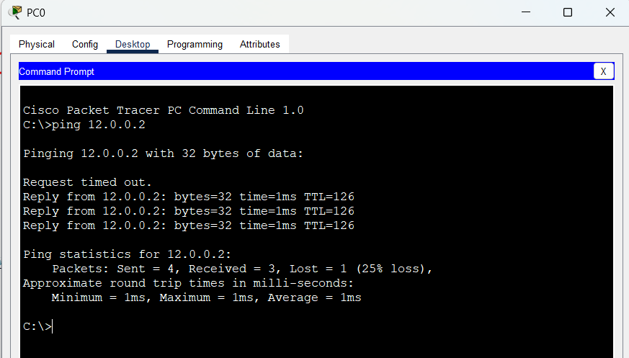**Step – 9 :-**  now we will check connection using ping command.

**Step – 10 :-**  using tracert ip_add command we can check how packet will be reach at ip add.

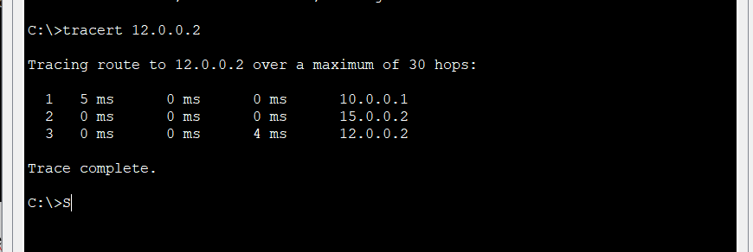

**Step – 11 :-**  using s hip route command we can analys=zethe routing table of router.

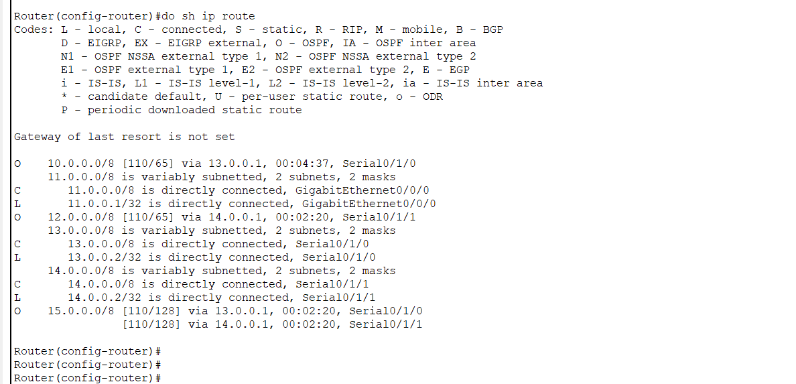

**Conclusion :-**

Through this experiment, I learned the importance of dynamic routing protocols in facilitating communication between different networks, specifically the OSPF routing protocol. How its working and how to configure it on router. Also learned new command tracert to tracing routing path.

By examining the output of the "show ip route" command, I analyzed the routing table and identified that:

* "O" (OSPF) signifies routes learned through the OSPF routing protocol.
* The absence of "Gateway of last resort is not set" suggests that there is no default route configured to handle traffic when no specific route matches.
* The routing table includes specific destination networks (e.g., 10.0.0.0/8, 11.0.0.0/8, 12.0.0.0/8, 13.0.0.0/8, 14.0.0.0/8, 15.0.0.0/8) and their associated subnet masks.
* The routing metrics in square brackets (e.g., [110/129], [110/65], [110/128]) provide information about the OSPF cost associated with those routes.
* The next-hop router for OSPF-learned routes is indicated by "via" (e.g., via 12.0.0.2).
* The time information (e.g., 00:02:00) shows the age of the routing information, indicating when the routes were last updated.
* The interface through which the router is connected to the specific network is mentioned (e.g., GigabitEthernet0/0/0, Serial0/1/1).
* The "C" and "L" routes are directly connected, indicating that the router is physically connected to these networks and IP addresses.
* Overall, the routing table contains a mix of directly connected, OSPF-learned, and static routes, each with its specific destination network, metrics, next-hop information, and interface details.